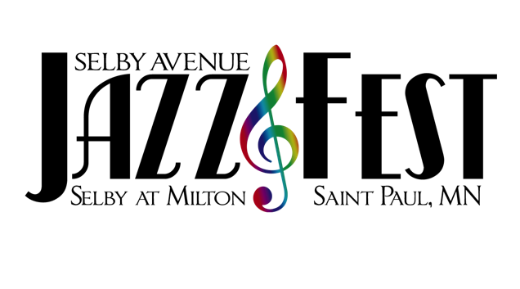Golden Thyme Coffee Café &
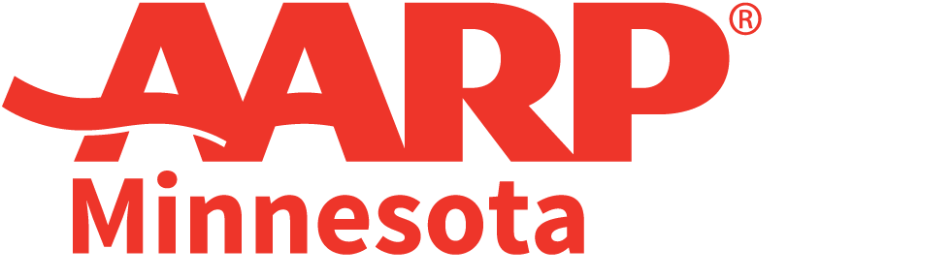

Present:

2 0 2 2 V E N D O R A P P L I C A T I O N

Business Name: ____________________________________ Contact Name: _________________________________

Address: ________________________________________________________________________________________

City: ______________________________________ St: __________________ Zip: ___________________________

Phone: _____________________ E-mail: _______________________ Website: _______________________________

Please provide a brief description of your business (and menu if applicable; please include any attachments that will assist in telling your story).

_______________________________________________________________________________________________

_______________________________________________________________________________________________

 | Food Booth-$350 |  | Political Booth-$300
 | Artist Booth*-$150 |  | Nonprofit Organization-$150
 | Business Booth**-$200 |  | Major Corporation***-$500 +

IMPORTANT VENDOR DEFINITIONS: An artist booth* is defined as a space where the vendor is actively engaging in live demonstrations of their profession and talents—painting, creating jewelry, sketching, carving, etc. A business booth** is defined as a vendor who is retailing an item or service. Though they could be retailing an art-related item, a business booth vendor is not engaged in demonstrating the actual creation process. For example, a vendor whose booth features pre-made jewelry and is not engaged in actually making additional product on-site is defined as a business booth. Major corporations*** preferring to rent a booth space (vs. sponsoring the event) will be charged a minimum of $500.

All booths are 10’ x 10’; food booths are 12’x 12’. Food vendors must include a copy of their city permit and have appropriate insurance. Vendors are responsible for taking all related trash to provided receptacles. Failure to keep a clean one’s area will seriously jeopardize participation in future Fests.

VENDOR POLICIES:
1. All vendors MUST provide pop-up style tent with weights to hold it down (no stakes; booths are on the street), tables & chairs.
2. Mail your check, payable to Selby Avenue JazzFest, and this completed form to: 2022 Selby Ave JazzFest c/o Golden Thyme Coffee Café, 934 Selby Ave, St. Paul, MN 55104
3. A NOTE ON COVID: The Selby Ave JazzFest will be strictly following the CDC guidelines at the time of the event.
4. As it has been for 21 years, JazzFest is a rain or shine event. No refunds will be given due to weather or acts of God. Please plan accordingly.

QUESTIONS:
FOOD VENDORS: Please contact Mychael Wright at 651.207.5945 or jazzfest.mw@gmail.com
ALL OTHER VENDOR INQUIRES: Please contact Stephanie Wright at 651.207.5945 or jazzfest.sw@gmail.com
COMPLETED APPLICATIONS ARE DUE BY FRIDAY, AUGUST 12th

___________________________________________________________________________________________________________________________________________________________________________________________________________________

For Internal Use: Ck # _____________ Cash: ______________ Rec’d: _____________ Deposited: ___________

